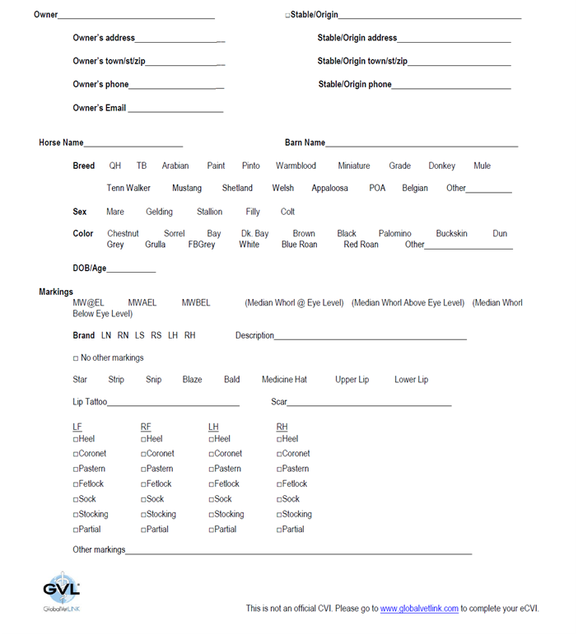

**Microchip ____________________**

**County ________________________**

**County ________________________**

**\*\*Fill out stable information if physical location of horse is not the same as mailing address.\*\***

**Registered Name**

***Both Pages must be completed in full and sent in at least 3 business days prior to needing the health certificate in order for it to be issued on time. If the form is incomplete it will be returned which could possibly delay departure. Please indicate N/A if items do not pertain.***

**Destination Name**______________________________________________________

**Destination address** ____________________________________________________

**Destination town/st/zip/county**__________________________________________

**Destination phone**______________________________________________________

**Destination email** **if available** _____________________________________________

**Method of Transport**  _____________________________________________

***Both Pages must be completed in full and sent in at least 3 business days prior to needing the health certificate in order for it to be issued on time. If the form is incomplete it will be returned which could possibly delay departure. Please indicate N/A if items do not pertain.***

***OFFICE USE ONLY:*** *Dr._________________________ Date________________*

*Temperature_______________ Verified Brands: YES / NO - Photos if applicable*

*Pictures Taken: YES / NO ID/Microchip________________________*

**Test Date:** _________________________

**Accession #:** ________________________

**Result & Date of result:**_______________

**If we did not do the Coggins at our clinic we need the following information along with a copy of the Coggins.**

**Name:** _EIA (coggins)_

**Type of test**: _(circle one) Elisa or AGID____

**Name & Lab address:** __________________

**Lab town/st/zip**_____________________

**Name of Carrier** _______________________________________________________

**Carrier address** _______________________________________________________

**Carrier town/st/zip/county__**____________________________________________

**Carrier phone**_**_**_______________________________________________________

**Carrier email** **if available** _______________________________________________

**Purpose for Travel _____**_______________________________________________